#203
Product Description: |  |  |  |  |  |  |  |  |  |  |  |  |  |  |  |  |  |  | Product Film Type:
Product Generic ID#: |  | C1U0050GI49 |  |  |  |  |  |  |  |  |  |  |  |  |  |  |  |  | 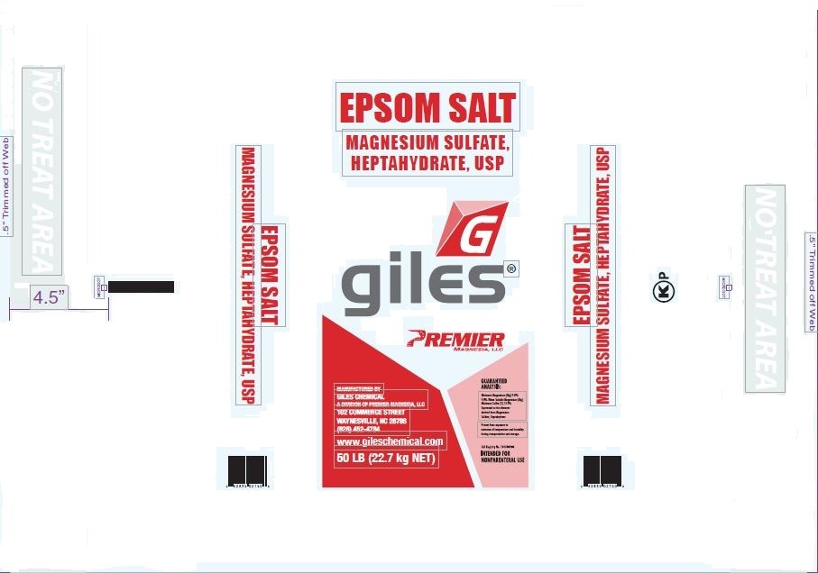
Product Grade: |  | USP
Product Screen: |  | Screened Middles
Packaging Weight: |  | 50lbs
Pallet Configuration: |  | 7X7 49bags
Other:
Quality:
 | - Samples to be taken |  |  |  |  |  |  | Retained for: |  |  |  |  |  | One small zip lock bag sample from screened salt chute every hour.
 | - Testing Required |  |  |  |  |  |  | Testing for: |  |  |  |  |  | pH greater than 6.0 / Test like ARCH
 | - Quality Release |  |  |  |  |  |  | Criteria Needed: |  |  |  |  |  | Finished product pH must be greater than 6.0 (USP testing)
Production/Packaging:
 | - Shrink Wrap |  |  |  | - Liners Required |  |  |  |  |  |  |  |  |  |  | - Heat Treated Pallets |  |  |  |  |  |  |  |  |  |  | - Stickers Required
 | - Extra Placard or Tag Required: |  |  |  |  |  |  |  |  | Description: |  |  |  |  | SCREENED MIDDLES
 | - Other Requirements: |  |  |  |  |  | Description:

Shipping:
 | - General |  |  | - Air Bags |  |  |  |  |  |  |  |  | - Double Wrap |  |  |  |  |  |  |  |  |  |  | - Corner Boards |  |  |  | - Block & Brace
 | - Must have Quality Approval signature before loading: |  |  |  |  |  |  |  |  |  |  |  |  |  |  |  |  |  |  | Reason:
 |  |  |  |  |  |  |  |  | Signature: |  |  |  |  |  |  |  |  |  |  |  |  |  |  |  |  |  |  | Date:
 | - Must have Management Approval signature before loading: |  |  |  |  |  |  |  |  |  |  |  |  |  |  |  |  |  |  |  | Reason:
 |  |  |  |  |  |  |  |  | Signature: |  |  |  |  |  |  |  |  |  |  |  |  |  |  |  |  |  |  | Date:
 | - Other: |  | Must load Quality designated load and must load correct amount.
Change Information: |  |  | Update to new template, removed references to ARCH.

